Question 1

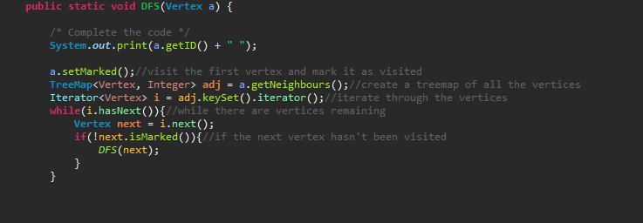

Question 2

Preferred data type is a string where we assume that the first 3 characters are the shortened month values, followed by 2 characters that denote the day of the month. For example, the 12th of January is represented as “Jan12”, and the 2nd of February is “Feb02”.

* Split the string into the month and the day using substring, then compare each portion to see if the values match.
* Could check for same month first and then check for same date. This will be faster than checking a value compared with 365/364 other values

Pseudocode:

Boolean SameBirthday(string d)

If(n<=365 || LeapYear && n<=366){

Return true;

}